Contractor HSE Audit IA-2026-05
Atlas Marine Contractors – MV Sea Atlas (WE-CON-2025-040)
Hannah Weber · 01 July 2026 · IA-2026-05

1. Background
This audit was brought forward after the high-potential near miss HSE-INC-2026-018 on 3 June 2026. It focused on dropped objects prevention, lifting operations, permit to work and the bridging document between Weyland and Atlas Marine Contractors. The audit took place on board MV Sea Atlas on 24 June 2026 (Yusuf Demir, lead; Felix Brandt; HSE superintendent of Atlas Marine).

2. Findings
No. | Type | Finding | Status (1 Oct 2026)
1 | Major NC | DROPS register for the pile gripper frame did not exist before 3 June; survey now completed but 11 secondary retention items still missing | Open – 3 items remaining
2 | Minor NC | Tool tethering rule implemented, but 2 of 9 inspected tool bags contained untethered tools | Closed
3 | Minor NC | Lift plans for routine lifts not signed by the person in charge on 4 of 20 sampled | Closed
4 | Minor NC | Permit to work audit trail incomplete for night shift (3 permits) | Open
5 | Observation | Fatigue: crew working 21 consecutive 12-hour shifts within limits but at upper end | Closed – rota adjusted
6 | Observation | Good: crew described the stand-down as useful; near miss reporting up by 40 % | –

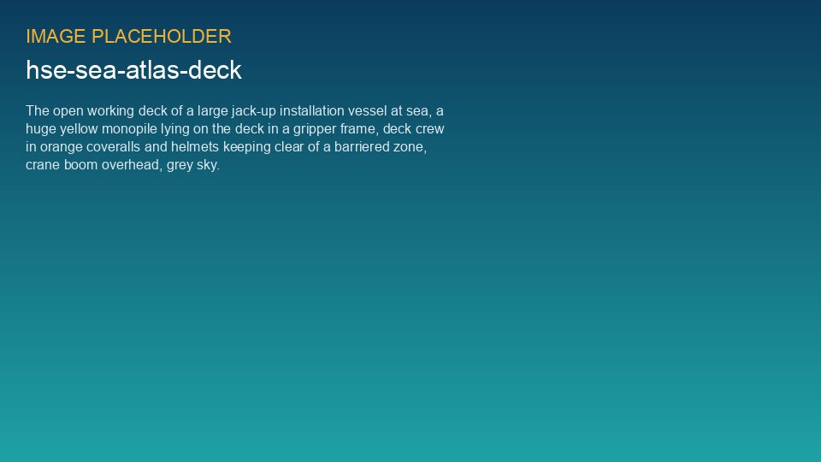
Audit on the main deck of MV Sea Atlas

3. Conclusion
Atlas Marine Contractors responded quickly and constructively to the near miss. The remaining open items must be closed before the next monopile campaign phase in October 2026. Follow-up audit planned for October.

